BEACON system design

17/07/2018 – Richard bamford – redditsat

# Context

**The beacon system will transmit core information about the satellite to the ground station.**

The outputs of this system are to be transmitted to the ground station.

The inputs are sent to the Atmega chip.

This program will require minimal storage since it acts as a relay for the system/battery information and the ground station. The values stored should be held in EEPROM see requirements 2 & 3 for more detail.

# Outputs (transmitted TO GROUND STATION)

* 9 solar panel voltages – mV - float
* Battery voltage – mV - float
* Battery charging current – mA - float
* Reset count – integer
* Identification – integer

# Inputs (TO Atmega CHIP ONBOARD)

* 9 solar panel voltages – Unknown format
* Battery voltage – Unknown format
* Battery charging current – Unknown format

# Requirements

1. 11 input channels
   1. 9 solar panel inputs
   2. Battery voltage
   3. Battery charging current
2. Reset counter
   1. Read from EEPROM to RAM on setup and increment value.
3. Identification number
   1. Read from EEPROM to RAM on setup.
   2. Write to EEPROM using function which is deactivated after initial value set.

# Flow Diagram

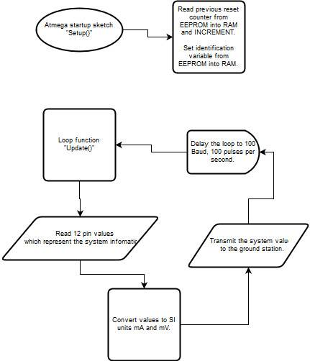

Figure - Flow chart for the beacon atmega arduino sketch.